**Project Design Phase-II**

**Data Flow Diagram & User Stories**

|  |  |
| --- | --- |
| Date | 22 May 2025 |
| Team ID | LTVIP2025TMID20310 |
| Project Name | Resolvenow: Your Platform For Online Complaints |
| Maximum Marks | 4 Marks |

**Data Flow Diagrams:**

A Data Flow Diagram (DFD) is a traditional visual representation of the information flows within a system. A neat and clear DFD can depict the right amount of the system requirement graphically. It shows how data enters and leaves the system, what changes the information, and where data is stored.

Example: DFD Level 0 (Industry Standard)

**Example:**

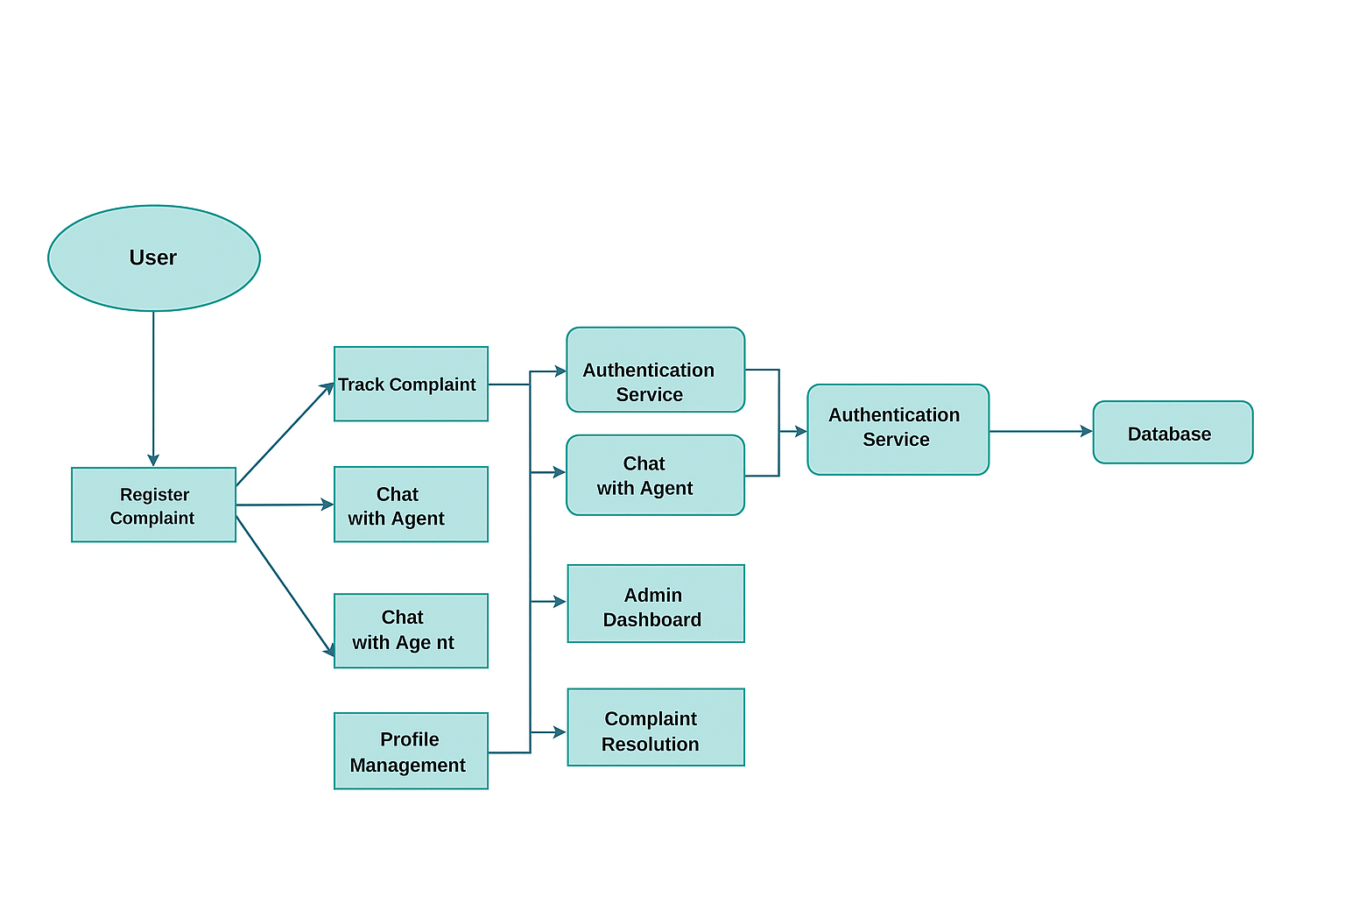

**User Stories**

Use the below template to list all the user stories for the product.

| **User Type** | **Functional Requirement (Epic)** | **User Story Number** | **User Story / Task** | **Acceptance criteria** | **Priority** | **Release** |
| --- | --- | --- | --- | --- | --- | --- |
| client |  | USN-1 | As a client, I can register for the application by entering my email, password, and confirming my password. | I can create an account easily | High | Sprint-1 |
|  |  | USN-2 | As a client, I can submit a complaint by filling out a detailed form. | I can Submit a Complaint quickly | High | Sprint-1 |
|  |  | USN-3 | As a client, I can view the status of my submitted complaints. | I can check the status of my complaint | High | Sprint-2 |
|  |  |  |  |  |  |  |
| Admin |  | USN-1 | As an admin, I can assign complaints to agents for resolution. | I can easily assign complaints to respected agents | High | Sprint-1 |
|  |  | USN-2 | As an admin, I can monitor system activity and manage users and agents. | I can monitor the system | High | Sprint-1 |
|  |  |  |  |  |  |  |
| Agent |  | USN-1 | As an agent, I can see all complaints assigned to me and update their status | I can see and update complaints | medium | Sprint-2 |